**NEPAL**

Dry matter generation

Total dry matter generation during 2016 – 2017 in Gg (Das et al., 2020)

|  |  |  |  |  |
| --- | --- | --- | --- | --- |
| **Rice** | **Maize** | **Wheat** | **Sugarcane** | **Jute** |
| 6670 | 1840 | 2340 | 854 | 11.3 |

Emissions from crop residue burning in Gg (2003-2004 and 2016-2017) (Das et al., 2020)

|  |  |  |  |  |  |  |  |  |  |  |
| --- | --- | --- | --- | --- | --- | --- | --- | --- | --- | --- |
| **Year** | **CO2** | **CO** | **CH4** | **SO2** | **OC** | **PM2.5** | **BC** | **NOx** | **NMVOC** | **NH3** |
| 2003-2004 | 3250 | 120 | 5.1 | 0.9 | 6.7 | 19.2 | 1.7 | 5.5 | 17.6 | 2.1 |
| 2016-2017 | 4140 | 154 | 6.5 | 1.2 | 8.6 | 24.5 | 2.2 | 7.0 | 22.5 | 2.7 |

February to May accounted for **86.16%** of the total emissions, with the peak occurring in April. No emissions occurred between July and September (Das et al., 2020).

**PAKISTAN**

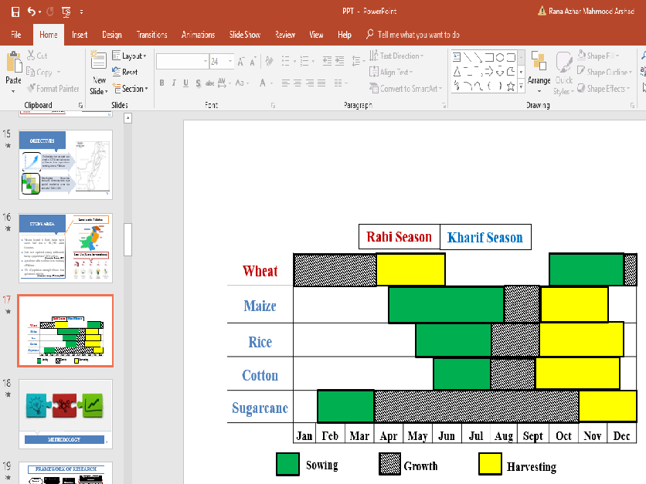

1 Agriculture pattern in Pakistan (<http://namc.pmd.gov.pk/crop-calender.php>)

Total emissions in Pakistan due to 4 major crops (Wheat, maize, sugarcane and Rice) : 21Tg

Agricultural residue burning has also been identified as second largest source contributing to organic carbon (OC) in PM2.5 in urban areas of Pakistan, consequently making the air quality of bigger cities (e,g, Lahore) ranked amongst the worst globally. Similarly, emissions from crop residue burning and other anthropogenic activities are reported to be significant enough to influence the variability of gaseous pollutants e.g. CO in the region. Combined with favorable meteorological conditions of low mixing height and low wind speeds in the Indo-Gangetic plain, the pollutants emitted by **biomass burning during October–February, significantly contribute towards near-ground-formation of thick haze, which covers the region from west to east.**

Total residue generated for selected crops was 62.47 Tg

20 Tg was burned on fields during 2014.

Largest share (48%) was that of wheat, followed by rice straw and sugarcane leaves (23% each). Maize straw contributed around 6%.

2 Crop Residues burned on field during the year 2014 (Azhar et al., 2019)